COUNTY COUNCILLOR REPORT
TO
ALL PARISH COUNCILS
IN PETERSFIELD HANGERS

1 APRIL 2026

- Hampshire Devolution deal is now pending Parliamentary approval

I mentioned in my 2026 Annual Report in March that the Labour Government’s decision to delay the Mayoral elections (to 2028) was disappointing and damaging for Hampshire. Hampshire really needs a Mayor to fight its corner.
This month there is a silver lining to report: the devolution of powers and funding to the new Hampshire and the Solent Combined County Authority (HSCCA) is now proceeding. The funding will focus on boosting economic growth and encouraging innovation among local businesses. This is good news for Hampshire.
On 16 March 2026 a statutory instrument (SI) was presented to Parliament, which will legally set up the HSCCA and define its initial responsibilities and how decisions will be made. An Interim Chief Executive, Dr Ruth Adams, has been appointed, with temporary staff to fill key roles including Chief Financial Officer and Monitoring Officer to ensure legal operations. The recruitment of permanent staff has started.
To support the establishment of the HSCCA it will receive 40% of its investment fund each year, together with additional funding to support the HSCCA’s internal capability, for the financial years 2026/27 and 2027/28. This approach will support the organisation to set up and take on its new responsibilities. The full investment fund will then be released when a Mayor is elected in 2028, ensuring that the HSCCA is fully resourced to deliver transformative changes across the region. Its main areas of responsibility will include:

- Transport: Responsibility for developing and implementing integrated transport strategies that improve connectivity across the region.
- Skills and Employment Support: Authority over adult skills funding, driving upskilling opportunities, and supporting pathways into high-quality employment.
- Housing and Strategic Planning: The power to prioritise and deliver new housing developments and support the provision of affordable homes.
- Economic Regeneration and Development: The ability to attract and retain national and international investment ensuring the region capitalises on its economic strengths.
- Environment and Climate Change: Implement initiatives for the region to reduce carbon emissions, promote sustainability, and protect natural habitats.
- Health and Wellbeing: Work closely with local partners to reduce health inequalities and support healthier communities.
- Public Safety: Working with Police and Crime Commissioner and the Fire and Rescue Authority, enhance safety by supporting collaborative approaches to emergency planning, community resilience, and crime prevention.

Leaders from Hampshire, Isle of Wight, Portsmouth, and Southampton councils will work together, alongside other board members, on priorities that reflect the needs of local communities.
Councillor Nick Adams-King, Leader of Hampshire County Council, said: “This important legislation now before Parliament will enable our region to shape its own economic priorities, giving us the powers and tools needed to drive growth and improve outcomes for local people. It presents a huge opportunity for local leaders, businesses, and communities to work together to unlock our area’s full potential.”

- Local Government Reform update

You will probably have seen the reporting in the press about the Government decision to create 4 mainland unitary authorities in Hampshire, as per the below map.

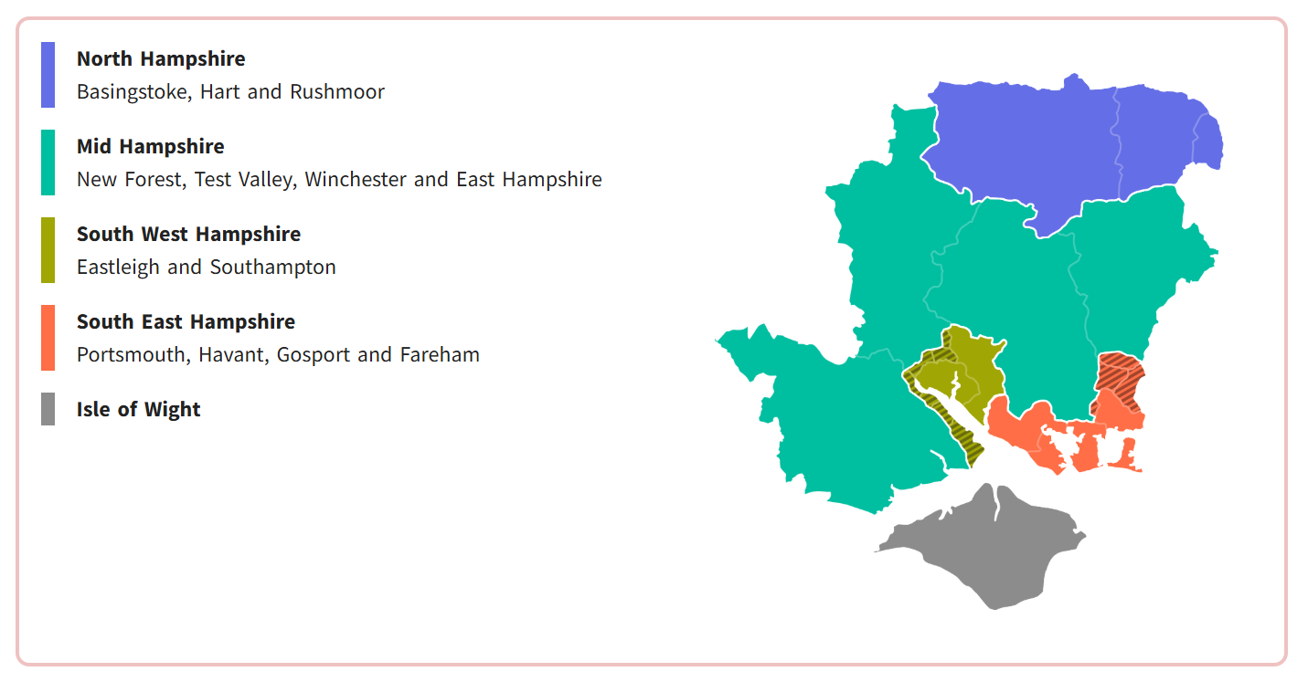

I am disappointed by the Government’s decision. The mid-Hampshire unitary is way too big and diffuse. Setting up the North Hampshire Unitary from scratch, with no anchor authority, will also be extremely expensive and risky. The benefits of LGR will be lower because we will have less opportunities for economies of scale. And in my view the break-up of East Hampshire is not in the interests of the residents of Horndean, Clanfield and Rowlands Castle. Or indeed the rest of East Hampshire.

I do accept that the Government has a right to make this illogical decision, and in Hampshire we will have to do our best to make it work.

- Green Light for Pulens Lane/Durford Road junction scheme

With this being my final report, it gives me great pleasure to be able to report that the implementation of the safety and traffic-calming scheme at this notorious junction is now imminent. I have discussed the scheme personally with the Leader of Hampshire County Council and he has reassured me that it will be delivered this year.

The scheme, which includes new traffic calming features and drainage upgrades, aims to address longstanding concerns about safety and flooding in the area. The scheme features raised areas of carriageway and a pinch-point at the bridge over Tilmore Brook. As a next step, the project proposal will be considered at the Executive Member for Universal Services Decision Day on 22 June 2026. The contractors should then start in late summer to early autumn 2026.
Ahead of the main works, preparatory drainage activity will take place to clear the existing gullies and the surrounding drainage network. This early work will help prepare the site for permanent drainage improvements and reduce the risk of local flooding at this location. Residents and local businesses will be kept informed via the dedicated project webpage:
Pulens Lane Improvements, Petersfield | Transport and roads | Hampshire County Council

- New process for roadworks notifications

I would like to inform you about a change to the way the Hampshire Highways team notifies local residents and businesses about planned maintenance works.

From today, properties in affected areas will receive a generic A5 sized flyer rather than a bespoke letter to notify them of forthcoming maintenance work in their area. The flyer will direct residents to a new dedicated webpage where they can find the most up to date information about upcoming work in their area. For high impact schemes, custom letters may still be used but this will be by exception.

This change will allow the Highways team to provide information that stays current and can be updated quickly if plans alter - such as changes caused by weather conditions or operational factors. Residents will therefore always have access to the very latest details, including revised dates, timings and traffic management arrangements.

The new approach also delivers a number of other benefits:

- Improved accuracy: Online information can be updated immediately, ensuring residents are not relying on printed letters that may become out of date.
- Efficiency savings: There will be reduced printing, postage and distribution requirements that will free up resources for delivering more work on the network.
- Supports digital service transformation: Most residents now access information online, and this change aligns with our wider move towards more flexible, digital-first communication channels.
- Environmentally positive: Using postcards will reduce paper use and waste.

The new process will generally not apply to short-term works, such as surface dressing (where the contractor will continue to deliver letters), or very localised repair work commissioned by the local depots. The website www.one.network will continue to show all roadworks including those undertaken by utilities. For National Highways' network, information will continue to be available on their website at www.trafficengland.com.

At HCC we recognise that a small number of residents may require additional support to access information online. Anyone needing assistance will still have access to the Highways Operation Centre via the standard telephone number.

- Update on the A272 Bridge repairs

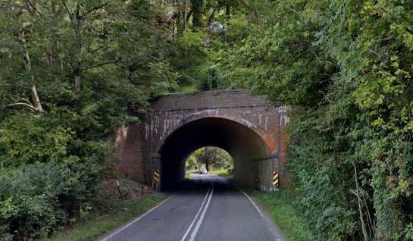

Following last year’s extensive repair works to the Victorian bridge on the A272 to the south of Privett, I have been in touch with National Highways and I would like to share some information.

During the works on site, the National Highways contractor Amco Giffen found more defects than were expected. They took some core samples during the works, and it is now evident that the bricks used to build the bridge were of a poor quality. Unfortunately, this means that the bricks are not as durable as one would normally expect. National Highways did look into extending the road closure last year to carry out further works, but the County Council did not allow this. Thank goodness for that. We all remember the traffic problems that occurred due to the poorly implemented diversions.

National Highways do not believe that the remaining defects represent a safety risk to the public. NH are now planning two night shifts at the structure to allow a “laser-point cloud survey” of the structure to be carried out. This will require single-way working under traffic lights with speed limited convoy operation for the safety of the workforce and the travelling public. There is no intention to close the road. There will likely be some minor delays to traffic, but I would agree with NH that traffic lights overnight is the best option to mitigate any delay to the travelling public and maintain a safe working environment.

NH will repeat this laser scan over future years. This will allow them to keep an eye on the repairs carried out and the areas of the structure they believe will require further work. Should they find that we need to return to carry out further works they have promised to let us know well in advance.

- His Majesty the King visits the South Downs National Park

I was delighted to see my friend Vanessa Rowlands, Chair of the SDNPA, shaking hands with the King on his recent visit to the South Downs to open the new Coastal Path. The visit marks a significant occasion for our National Park and I felt very proud.

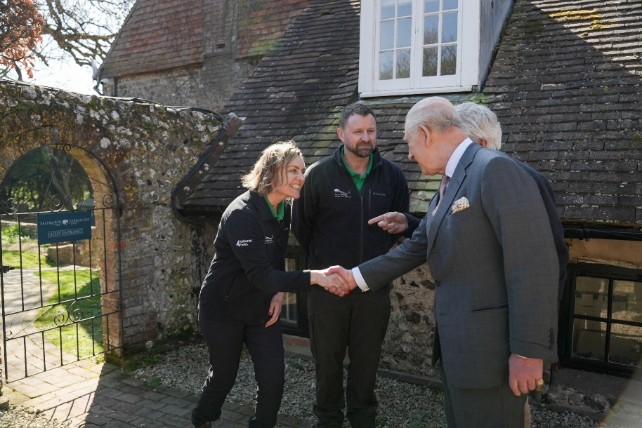

- Thank you and good luck with everything!

It has been a great honour to represent Petersfield Hangers at County for the last nine years. I have many wonderful memories and I am proud of many of our achievements. I wish you all the best with your future projects. I will also be sending my best wishes to my successor as County Councillor; I sincerely hope that it will be someone with strong knowledge of the area and substantial experience in business and local government.

I would like to thank you for all the fantastic work you do in your communities. Your work makes a real difference and I know that it is greatly appreciated by Parishioners. I will be working as a languages teacher in Farnham from September but I will still be living in Petersfield. I look forward to bumping into you all over the coming years.

RUSSELL OPPENHEIMER
County Councillor for Petersfield Hangers

